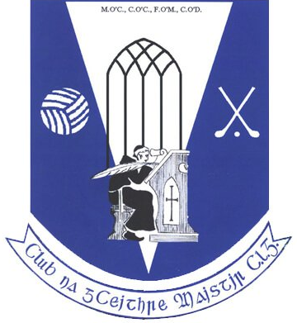
Four Masters GAA - Club Notes - 27th July 2020

Club Lotto
Congratulations to Peter Rooney, c/o Peter’s Manshop who scooped the Lotto Jackpot of €3,200 in Week 02 of the 2020/2021 season on Monday 20/07/20
Peter's lucky numbers were 5, 13, 19 & 21.
The next Lotto draw is Monday 27/07/20. New members are always welcome so why not play online before 3.00pm next Monday and be in with a chance of winning the €300 jackpot. Play now at https://clubforce.com/…/gaa-four-masters-g-a-a-club-donegal/

Junior Hurling Championship – Carndonagh v Four Masters 26/07/20
Carndonagh 2:12
Four Masters 0:04
Four Masters were beaten by a strong Carndonagh side in the Junior Hurling Championship on Sunday 26/07/20
Despite this loss the season is far from over for the hurlers and the opportunity to progress further in this year’s championship is still there.
Next up for Four Masters is an away game to neighbours Aodh Ruadh Ballyshannon on 7th August at 19.30
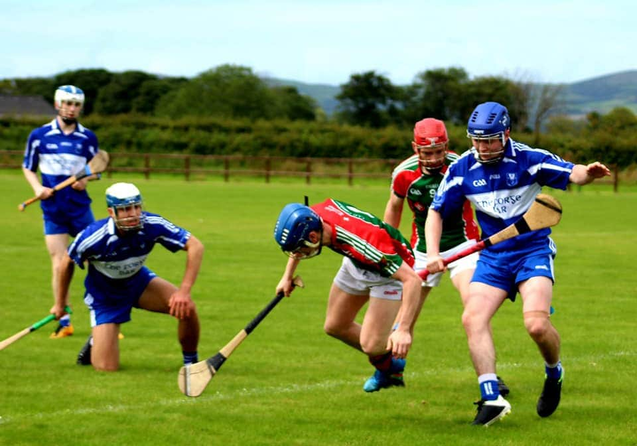
Regional Football League – Division 2, Group A - 25/07/20
Naomh Ultan 0:11
Four Masters – 0:08
Four Masters lost their second game of the Division 2 Regional League to Naomh Ultan in a hard fought game in Dunkineely on Saturday evening.
The home side got off to a strong start and led 8 points to 3 at half time.
Four Masters rallied in the second half with an increased share of possession, assisted no doubt by the home side being reduced to 13 men during the half.
Despite the numerical advantage, the visitors couldn’t break down the Naomh Ultan defence to get the scores they needed, and Naomh Ultan ran out deserving winners in the end.
Next up for Four Masters is a home Senior Championship game v Gaoth Dobhair next weekend.
Four Masters: Martin Cassidy, Cathal Canavan, Caolán Loughney, Brian Fagan; Jamie Crawford (0-1), Eoghan Curley, Aaron McCrea; Leo McHugh, Kevin McBrearty; Cian Hegarty (0-1), Matthew McKenna (0-1,f), Oisin Reid; Killian Faulkner, David Quinn (0-3,1f), Barry Dunnion, Neil Ward (0-1), Patrick Reid, Daire Quinn (0-1), Cathal Feeney, Eoin Gorrell, Thomas McGowan, Aidan McHugh.
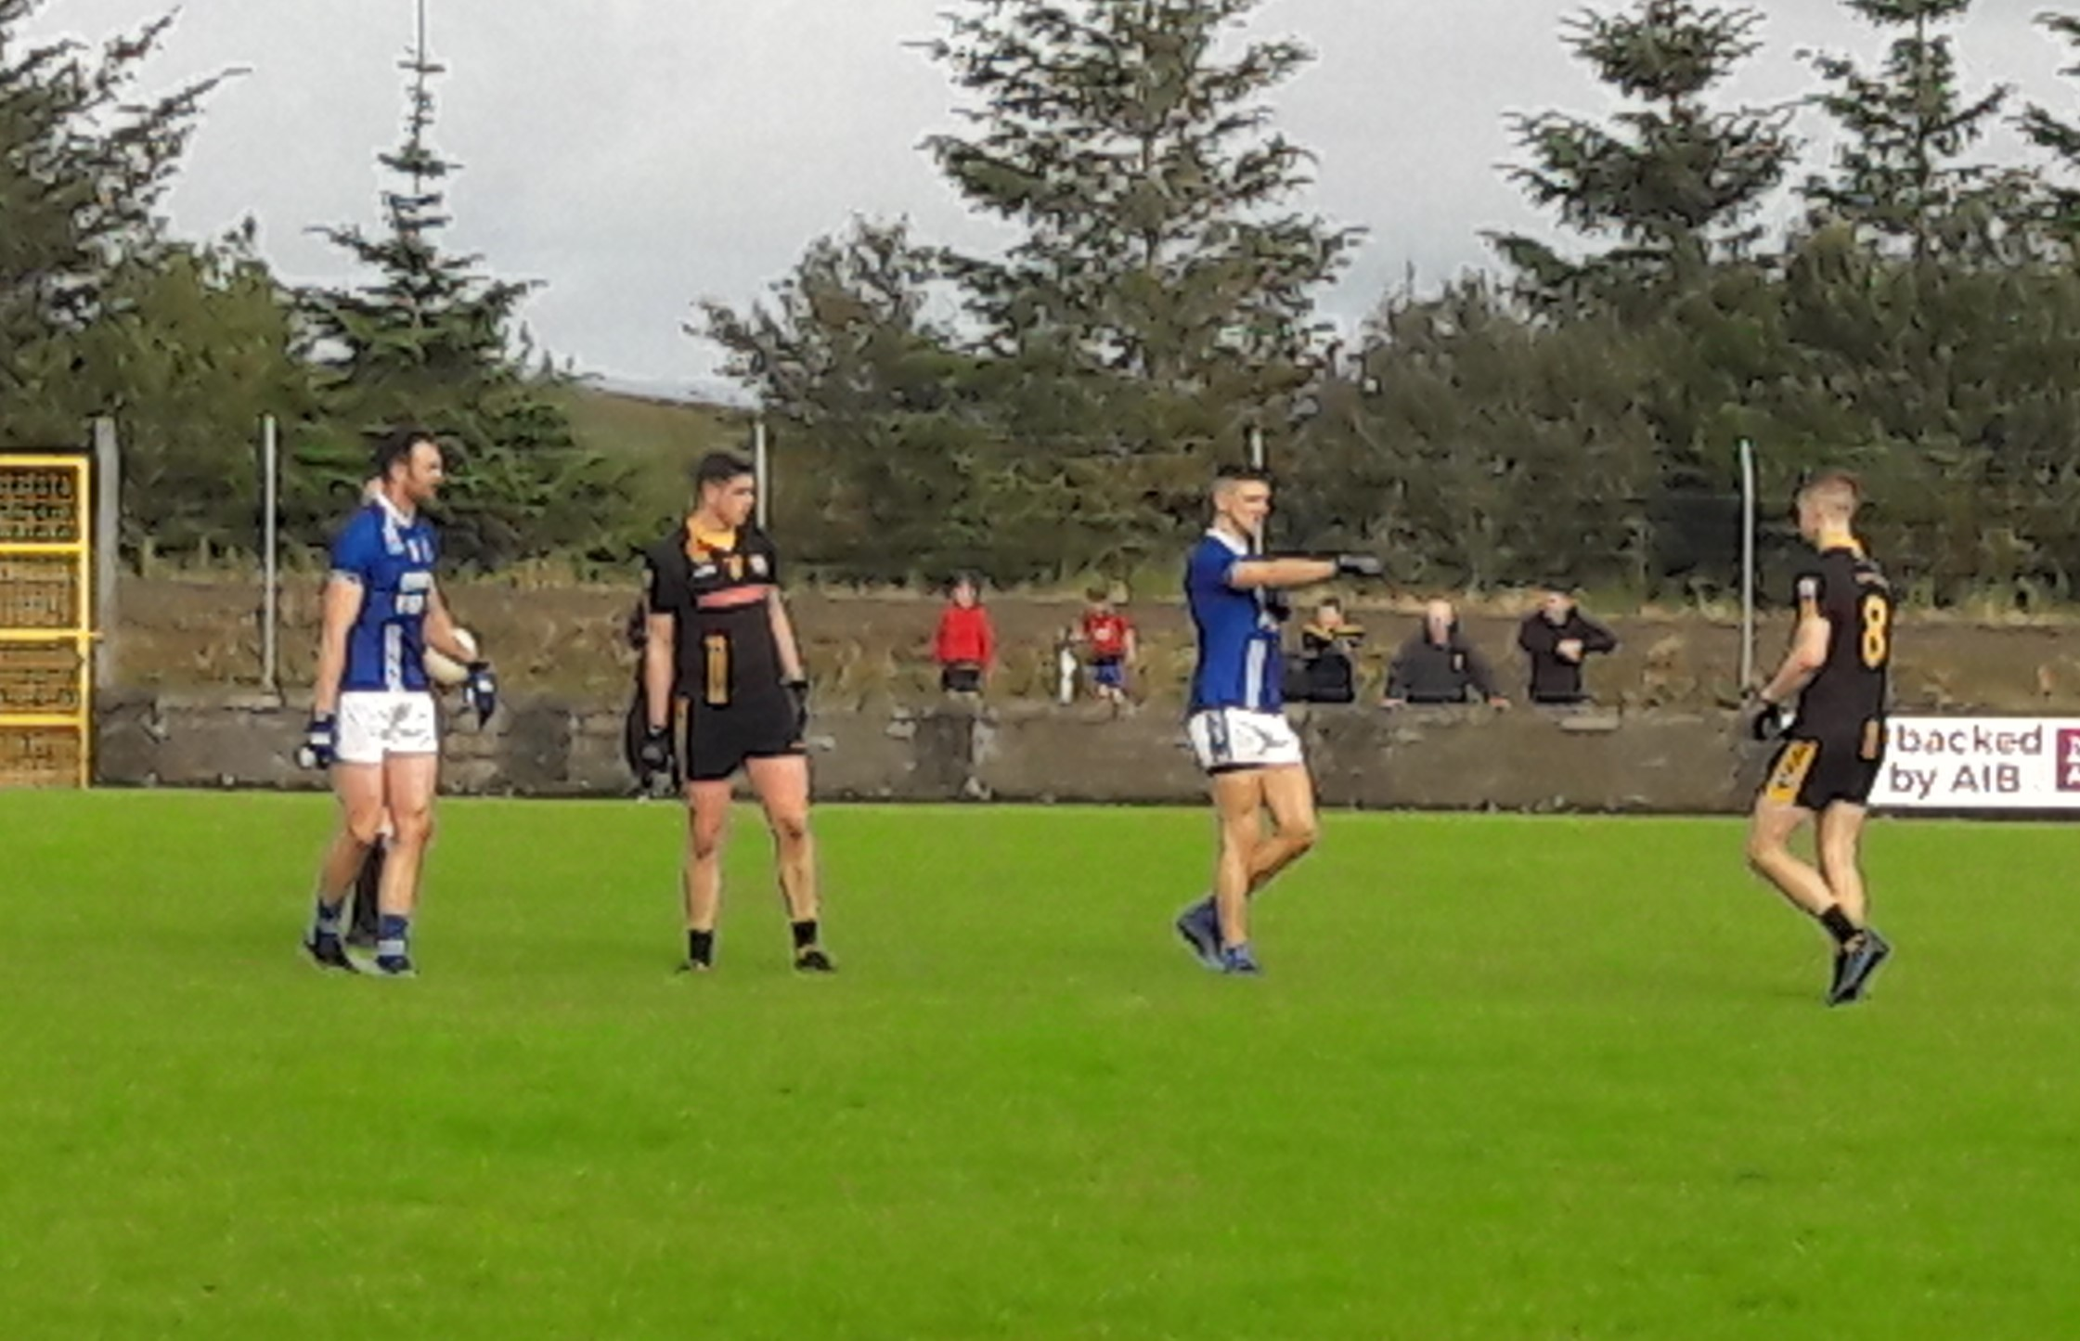
Naomh Ultan: Daniel McGlynn; Sean O’Shea, Michael Breslin, Chris Boyle; Anthony O’Shea, Dermot Gallier (0-2), Peter Alvey (0-2); Cian Kennedy (0-1,f), Sean White (0-1); Joe Alvey, Aidan Duddy, Dara Murrin (0-1), Aaron Kyles, Alan Lyons (0-3,2f), Daniel Gallagher, Damian Quigley, James Byrne (0-1).
Four Masters Reserves v Naomh Bríd – 21/07/20
Four Masters Reserves rolled into Regional League Division 2 action with a game against neighbours Naomh Bríd on Tuesday evening in Tir Conaill Park.
The pace, movement and scoring power of the home team proved to be too much for the visitors on the night, and Four Masters ran out comfortable winners in the end.
In particular some of the younger Four Masters players showed a keen eye for the goals and registered some very impressive scores over the course of the game.
Well done to Naomh Bríd who despite being on the defensive for large parts of the game, battled on to the final whistle.
Next up for Four Masters is an away game against Naomh Ultan on Tuesday evening 28/07/20.
Final Score:
Four Masters – 7:18
Naomh Bríd – 0:03
Teams and scorers:
Four Masters – Eamonn Jordan, Enda Bonner, Darren Walsh, Brian Peter Gallagher, Daragh Geary, Conor Rooney (0:01), Pauric Harvey, Hugh McPartland (0:01), Barry Monaghan, Alex McCalmont (2:03), Michael Doherty (1:02), Richard O’Rourke (0:01), Shay Travers (2:04), Conor McMonagle (1:04), Odhran Quinn (0:01), Conor McDaid (1:01), Phillip Myers, Sean Meehan, Shane Cannon, James McHugh, Conall Sweeney, Joe Leape
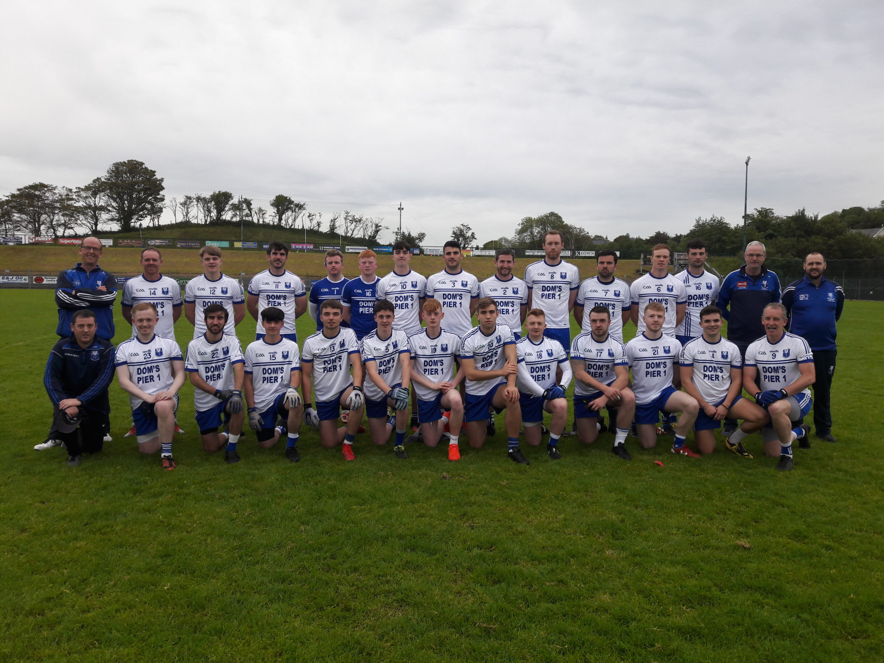
Naomh Bríd – Victor Mitchell, David Timoney, Michael Gallagher, Luke Burgess, Paul Diver, Conor McNulty, Thomas Gallagher, TJ Gallagher, Owen Rush, Eoin Quinn, Callam McGroary, Gerard Martin, Pauric McDaid, Christopher Price, Richard Walsh, Keelan Heeney, Michael Quinn, Henry Duignan, Ethan Mangan

Ladies Football Report
Another positive display from Four Masters Senior Ladies Squad today in Round 2 of the Intermediate Championship. Playing against Aodh Ruadh our Senior Ladies provided a good display, although the win that they crave continues to elude them. But they are working hard in training and will continue to try to keep improving.It doesn't get any easier as we host our neighbours St Nauls on Friday evening next at 7 in Tirconaill Park.
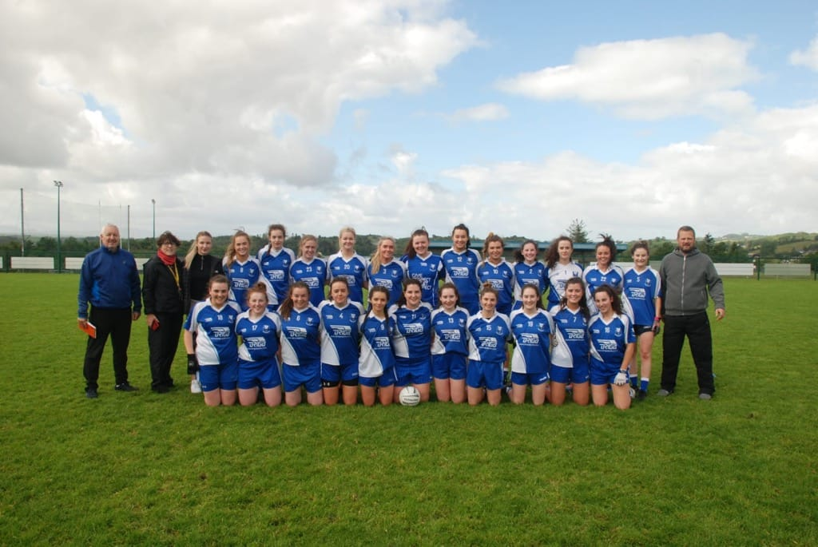
Under 10’s
Huge well done to our U10's who all took part in the ‘Solo for Livvie’ fundraiser on Saturday morning around the Bank Walk.

Donations can be made on their GoFundMe page at the below link:

https://www.gofundme.com/f/solo039s-for-livie…
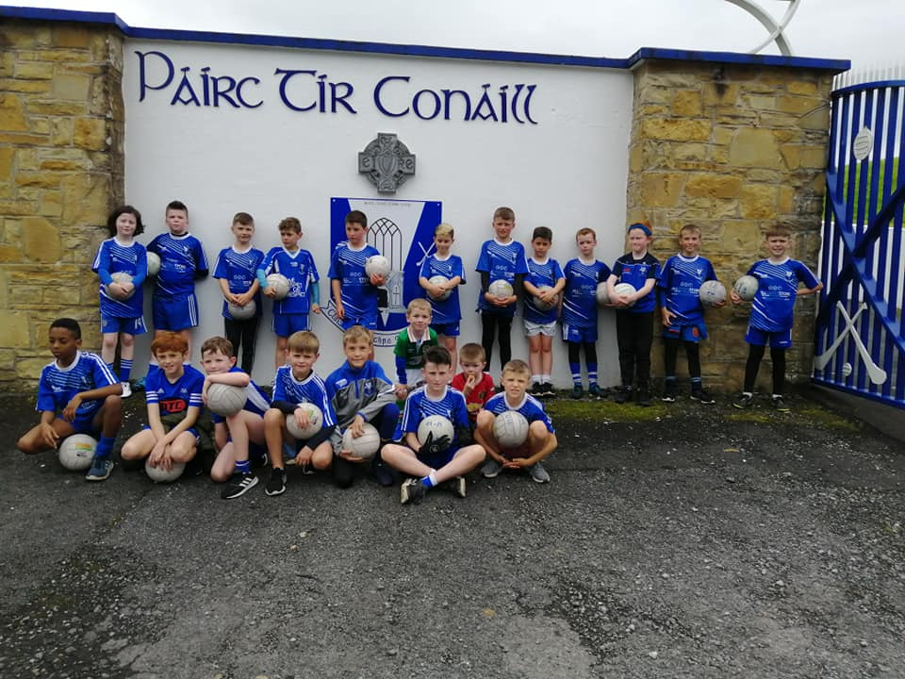

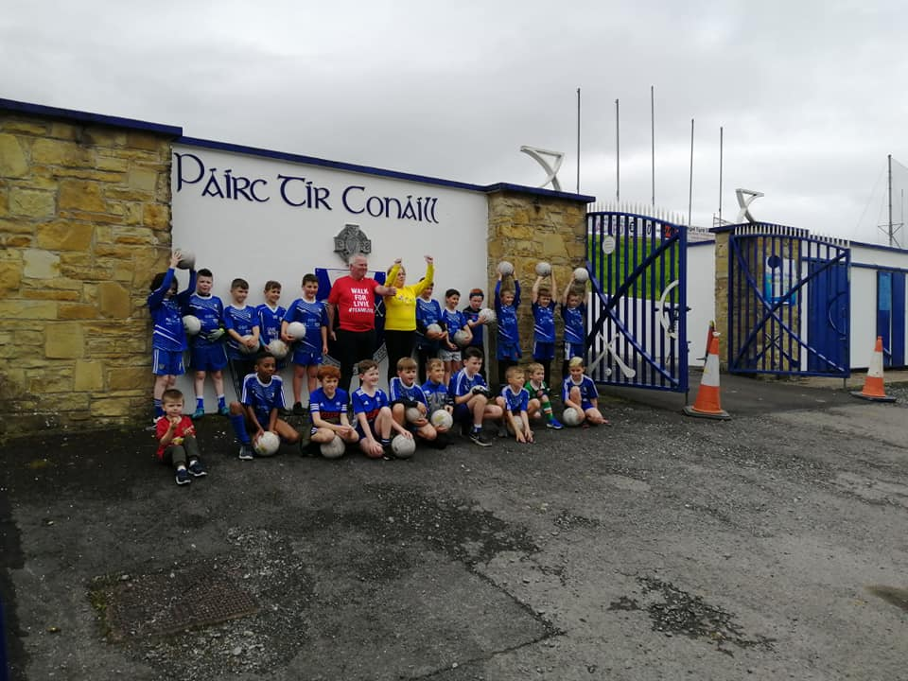
Win Your House in Dublin
Four Masters would like to encourage our club community to support the county board fund raising event in aid of the Centre of Excellence development in Convoy.
In addition to supporting the county project, each ticket sold by the club will generate a commission of €20 for the Four Masters Club itself.
Purchase a hard copy ticket now from Sean Dunnion, Paul Timoney, Barry Monaghan, Damien Dunnion or Pauric Harvey and you will earn your Club a €20.00 commission on each sale. There is a bonus draw this coming bank holiday weekend (win 2 nights B&B + evening meal in the Allingham Arms Bundoran PLUS 10 free tickets) so contact any of the above before Sunday August 3rd if you would like to be in that bonus draw
https://winyourhouseindublin.com/


Forthcoming Club Fixtures:
Divisional League Division 2 Section A RESERVE
Tue, 28 Jul,
Venue: Naomh Ultan, (Round: Round 2), Naomh Ultan V Four Masters 19:30, Ref: Pat Walsh

Michael Murphy Sports & Leisure Senior Football Championship
Sun, 02 Aug,
Venue: Four Masters, (Round: Round 1), Four Masters V Gaoth Dobhair 14:30, Ref: TBC

Home fixtures confirmed for this week:
Tuesday 6pm
U14 Boys B v Killybegs
Thursday 7pm
Boys U14 Hurling v Setanta
Friday 7pm
Senior ladies v St. Nauls
Saturday 11 a.m.
U14 girls v Glenties
Sunday 2.30 pm
Senior Men’s football v Gaoth Dobhar

